**Routing**

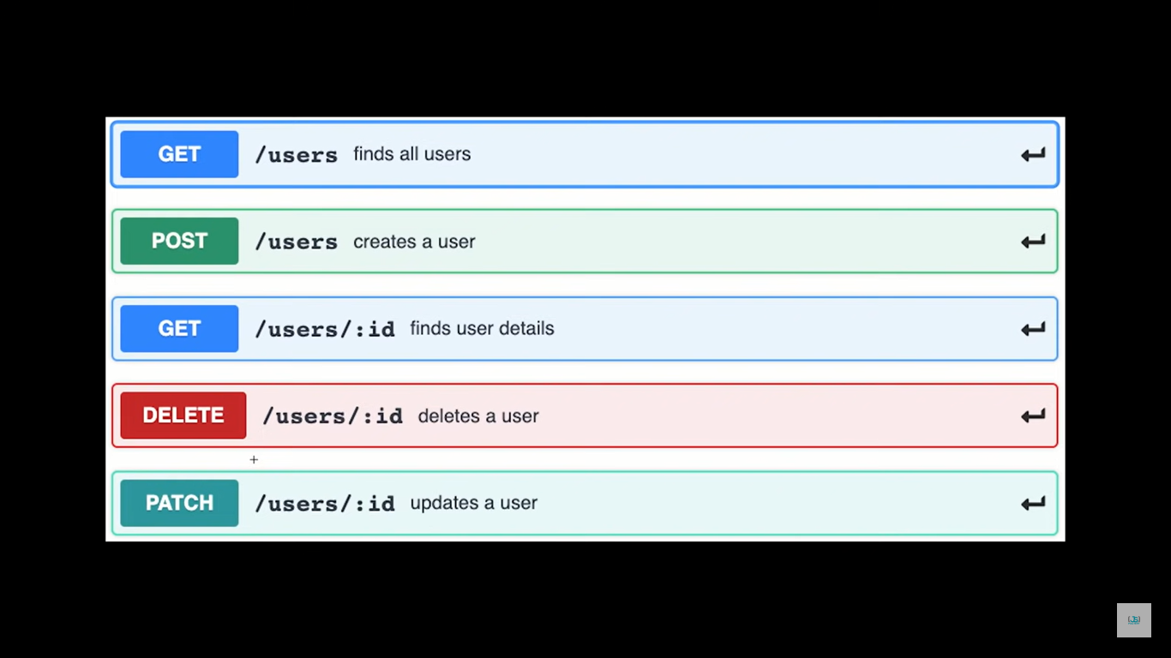

Let say we’re going to create a route for ‘/users’ then,

GET /users find all users

POST /users creates a user

GET /users/:id find users details

DELETE /users/:id deletes a user

PATCH /users/:id updates a user (updates a user details by id)